
GLIDER WINCHES

E11-E14 Wem Industrial Estate,
Wem, Shropshire, SY4 5SD ENGLAND
Tel: +44(0) 1939 235845
Fax: +44(0) 1939 234059
Website: www.skylaunchuk.com
Email: skylaunchwinches@yahoo.co.uk

Skylaunch Control Panel with presets for Glider type and headwind component:

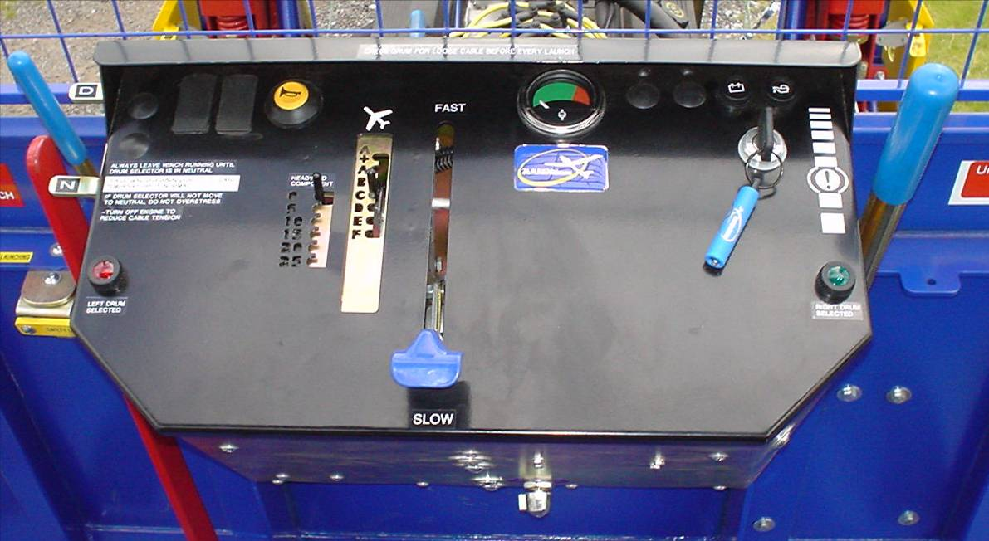
A
B
C
1
2
Blue Colour-Coded (Launch) Levers-
A) Transmission Select Lever (N>D)
B) Engine Throttle Lever
C) Drums Brake Lever (both Drums)

Black Throttle Pre-selects-
1) Headwind Speed
2) Glider Type
(See attached Throttle Setting Chart)

For safety, all controls are designed to operate as push to go, and pull to stop.

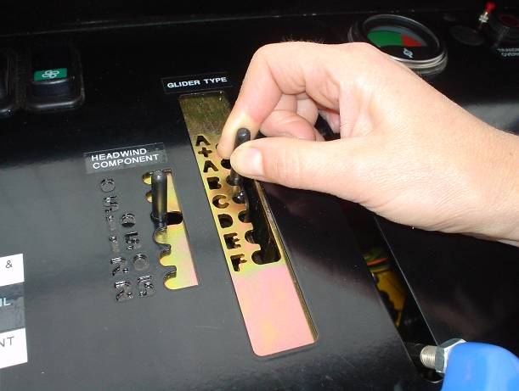
1
2
Before Launch (Black Levers):
Preselect Headwind Speed (1)
Preselect Glider type to be launched (2)
Select left or right Drum

To Tighten Cable (Blue Lever):
Select Transmission Lever to D Position (A)

To Launch (Blue Levers):
Apply Throttle to preselected guide stop (B)
Throttle damper controls correct acceleration rate

