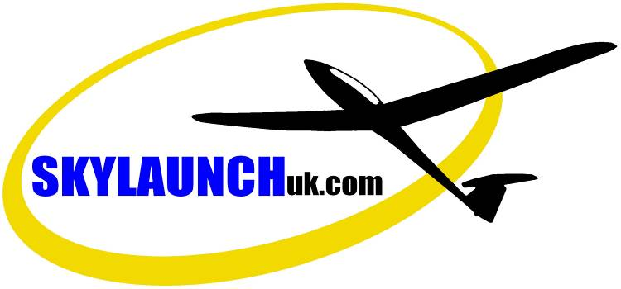
GLIDER WINCHES

E11-E14 Wem Industrial Estate,
Wem, Shropshire, SY4 5SD ENGLAND
Tel: +44(0) 1939 235845
Fax: +44(0) 1939 234059
Website: www.skylaunchuk.com
Email: skylaunchwinches@yahoo.co.uk

Quote for Planeurs d’ille-et-Vilaine, 24th October 2011

The new Skylaunch 2 “Evolution” uses many of the same components as the original Skylaunch 2 and 3 Models, and is mechanically very similar but with improvements including:

►The Cabin is much wider to give room for 2 x full size seats. Roof includes 5 opening ventilation hatches
►One-piece sliding Bonnet, easy opening to give full access to Engine, Cooling, Cable Guillotines etc. - similar to the Skylaunch 3. Also parachute tray fitted to front of winch.
►Large one-piece Clamshell type Winch rear and top Drum covers with gas spring assisters

►Reinforced Cable Drums for 1200m of Skyrope and Dyneema up to 3000m per Drum.
►High capacity housing Final Drive unit
►Improved design beltless single shaft radiator fan system

►Chassis 300mm longer- improves access and cable self pay-on onto large drums.
►Trailer sub-frame, Axles and Wheels manufactured as a separate unit (optional) then Winch mounted on top, to allow easy fitting to truck or trailer
►Improved stability for highway towing

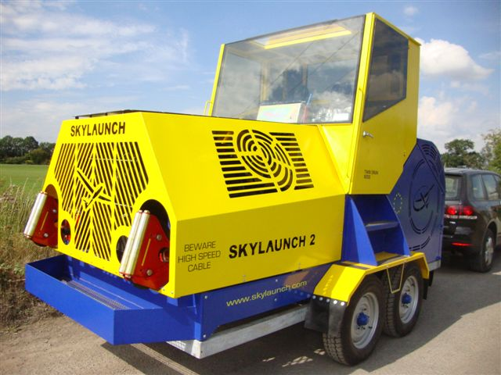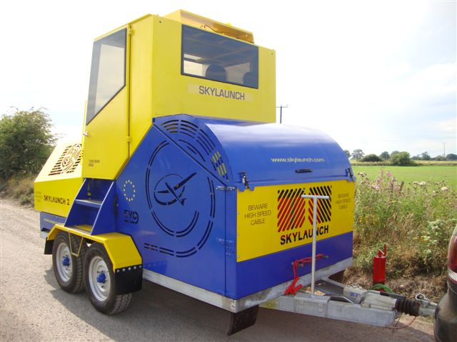

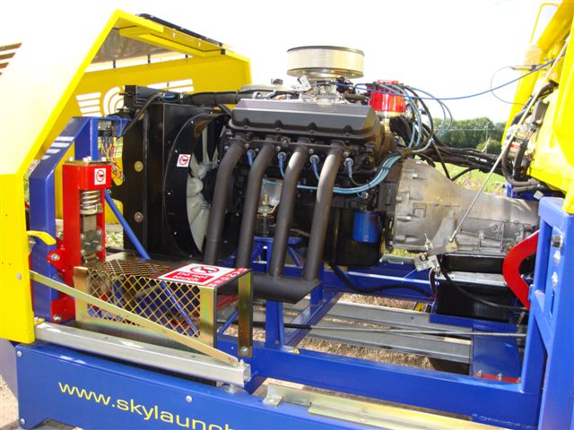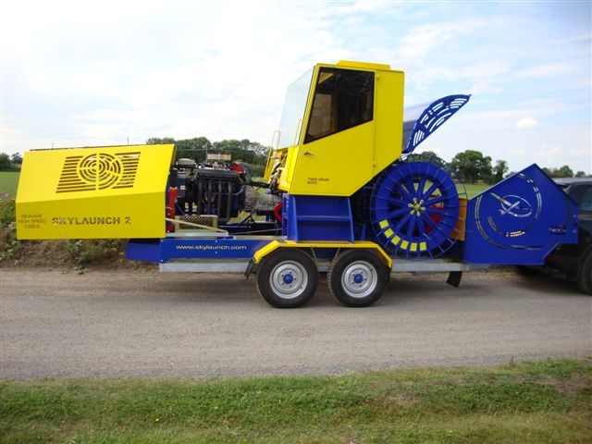

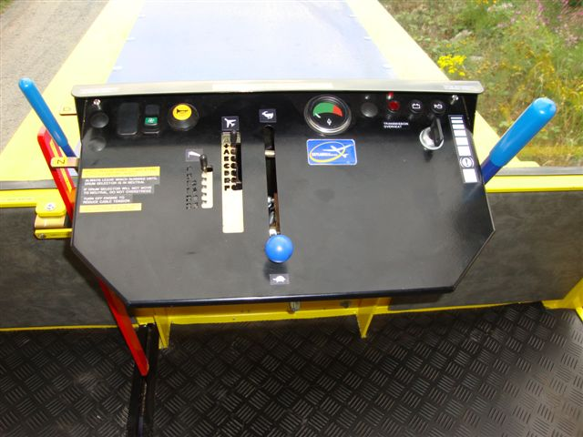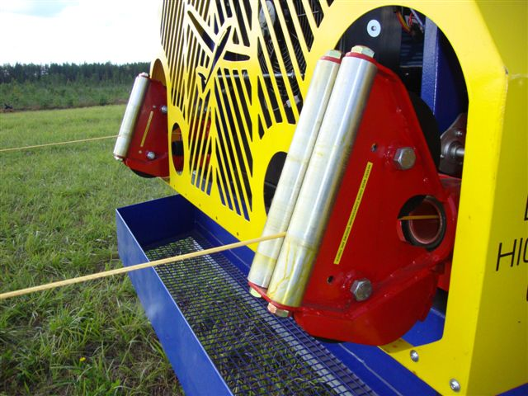

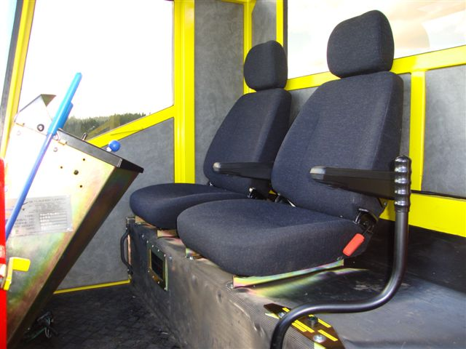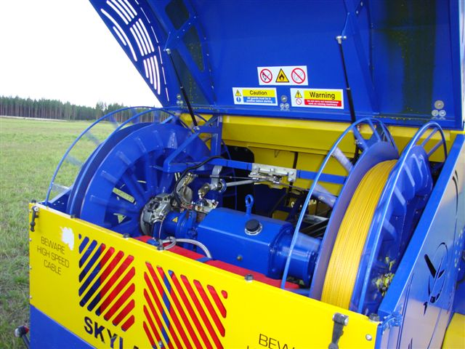

Above Photographs show Skylaunch 2 Evolution “Premium” model.
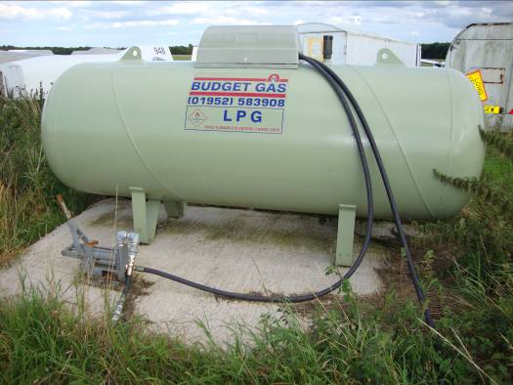
As our most popular and cost effective choice in Europe, we recommend LPG which has proven to be the simplest, most reliable and lowest running cost option.

Price for all new Skylaunch 2 Evolution twin drum glider winch, mounted on galvanized twin axle trailer sub frame, tested and ready to launch

Model | “Standard”  Model | “Premium”  Model
A. Powered by GM 7.4 Litre Engine on Petrol (Fuel Injection)  330 HP | £60,419.00  UK Pounds | £66,713.00  UK Pounds
B. Powered by GM 8.2 Litre Engine on LPG (Propan)  377 HP | £60,186.00  UK Pounds | £69,367.00  UK Pounds
C. Powered by GM 8.2 Litre Engine on Petrol (Fuel Injection)  400 HP | £62,164.00  UK Pounds | £71,339.00  UK Pounds

Price also includes delivery and full training in operation and maintenance at Gliding Club, assumes the Club provides food and accommodation for 1-2 persons for estimated 2 days.

Options | “Standard”  Model | “Premium”  Model
1. Cab rear weather shield, clear polycarbonate panel (Not required with option 2 or on “Premium” Model) | ADD  £243.00 | N/A
2. Enclosed Basic Cabin with 2 x doors and laminated safety Glass all round (tinted doors and rear). Includes roof rear-opening ventilation hatches. | ADD  £3,860.00 | Luxury Enclosed Cabin Included
3. Cabin Air Conditioning (only available in conjunction with an enclosed Cabin as option 2 for Skylaunch “Standard”) | ADD  £2,282.00 | ADD  £2,282.00
4. VHF AM Airband radio Icom IC-A110 (Fitted) complete installed with: brackets/mounts, Fist Microphone, Antenna, etc | ADD  £885.00 | ADD  £885.00
5a. EITHER:  9.6mm Skyrope 900m fitted to both Drums  (ie. 1800m total fitted to Winch) | ADD  £432.00 | ADD  £432.00
5b. OR:  5mm Dyneema Launch Cable 900m fitted to both Drums (ie. 1800m total fitted to Winch) Longer lengths of Dyneema available up to 3000m per Drum to suit length of Airfield. | ADD  £1,926.00 | ADD  £1,926.00
6. Launching Equipment Complete “Starter” Package for Twin Drum Launching–  2 x 17 metre rope traces including Stainless Steel ring and quick release hook.  4 x Heavy duty intermediate parachutes  5 x 3 Metre rope strops including Glider Rings, Stainless Steel Ring and braided Hose.  5 x Sets of Plastic H Section weak link housings, shackles weak links, parachute connections, quick release rings etc, etc. | ADD £700.00  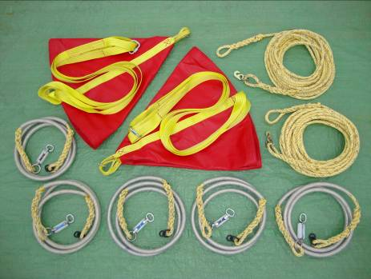

ALL PRICES EXCLUDE VAT, taxes and duties, etc. If no VAT number is supplied, UK VAT rate is 20%.

Prices quoted are valid until 31st March 2012

Skylaunch have a €Euro account but have quoted in £Pounds due to exchange rate fluctuations. Exact Euro rates for Invoicing can be advised at time of payment if required.

