SKYLAUNCH RE-ENGINEERING QUOTATION

Winch:_Tost Winch for Planeurs d’ille-et-Vilaine Date:___24 / 10 / 2011

Subject | Description | Fitted/ Condition | Recommendations
A) Final Drive | 1) Design (upside down or right way up?) | Upside down | Turn over, modify and re-engineer mounts, linkages etc.
 | 2) Brakes for cable drums | None | Skylaunch disk brake conversion
 | 3) Drive shafts | Usable | Service/ check over
 | 4) General condition | Usable | Service/ check over – overhaul if necessary
 | 5) Cable pay-on (Level wind) | Already removed | Not needed- Narrow drums
B) Cable drums | 1) Original drums condition/ design/ diameter | None | Modify Chassis + fit new drums
 | 2) Suitable for Skyrope/ Dyneema/ Steel Cable | Yes | Upgrade with additional webs + catch rails
 | 3) Safety drum covers | None | Manufacture new
c) Engine | 1) Type and capacity | 7.4 litre GM V8 | Relocate engine position with (Marine) rubber mounts
 | 2) Condition | Good | Service/ check over/ update  Option for new 8.2 Litre GM V8
 | 3)Fuel type/ system | Petrol | Original carburettor petrol or conversion to fuel injection or LPG system
 | 4) Exhaust system | Usable | Reuse/overhaul existing tubular system or fit Skylaunch system
 | 5) Cooling | Usable | Service/ check over, fit engine fans as required
 | 6)Fuel tank | None | Fit new/ used petrol or LPG tank
 | 7) Wiring/ plumbing | Poor | Rewire and renew pipework
D) Trans-  mission | 1) Type | GM T400 Automatic | Reuse but recondition
 | 2) Condition | Usable but locked in 3rd | Rebuild to use all 3 gears
 | 3) Cooling | Poor | Fit new fan assisted cooler with thermostatic control
 | 4) Prop shaft | Usable | Service/ overhaul + lengthen
 | 5) Prop shaft brake | None | Fit new system
E) Cable guillotines | 1) Design/ performance | Original Tost | Re-engineer with increased power for Skyrope or renew with Skylaunch Chisel Guillotines for use with dyneema
 | 2) Condition | Good | Re-engineer with increased power
 | 3) Actuation/ linkage | Poor | Renew with heavy duty system
F) Cable Roller box | 1) Design | Pulley/ roller type | Already overhauled by Skylaunch – suitable for use with Skyrope or renew with Skylaunch swivelling Pulley/Rollerbox system for Dyneema use.
 | 2) Condition | Very Good | Add counter balance weight
G) Controls | 1) Design | Poor | Re-engineer
 | 2) Launch control system | None | Fit Skylaunch control system
 | 3) Wiring, instruments, switchgear | Old | Renew or reuse some instruments and renew all wiring etc
 | 4) Controls, levers, etc. | Poor | Renew/ re-engineer
H) Cabin | 1) Design | Poor, no safety protection | Manufacture new, wider (1.1m) basic cabin with weld mesh screens
 | 2) Condition | Unsafe | See above
 | 3) Open/ closed | Open | Option for closed cabin with laminated safety glass and rear door
 | 4)Seat | None | Fit padded seat
I) Chassis | 1)Design | Usable | Re-use/ Modify
 | 2) Subframe, twin axles, wheels, hitch etc for highway towing | None | Fit all new
J) Bodywork | 1) Panels, safety covers | Most usable | New drum covers for new drums and other new guards, panels etc.
 | 2) Paint/ powder | Usable but poor | Respray in Skylaunch High Visibility Blue and Yellow

K) Prices

Serial | Engine Option | Price
1) | Powered by Original 7.4 Litre Engine on Petrol (Carburettor) | £33,926.00  UK Pounds
2) | Powered by Original 7.4 Litre Engine on Petrol (Fuel Injection) | £36,754.00  UK Pounds
3) | Powered by Original 7.4 Litre Engine on LPG | £35,615.00  UK Pounds
4) | Powered by all new GM 8.2 Litre Engine on LPG (Propan)  340 HP | £41,686.00  UK Pounds
5) | Powered by all new GM 8.2 Litre Engine on Petrol (Fuel Injection)  400 HP | £43,664.00  UK Pounds
Price also includes delivery and full training in operation and maintenance at Gliding Club, assumes the Club provides food and accommodation for 1-2 persons for estimated 2 days.

Options

Serial | Option | Price
L) | Enclosed Basic Cabin with 1 rear door and laminated safety Glass. | ADD  £2,360.00
M) | EITHER:  9.6mm Skyrope 900m fitted to both Drums  (ie. 1800m total fitted to Winch) | ADD  £432.00
N) | OR:  5mm Dyneema Launch Cable 900m fitted to both Drums (ie. 1800m total fitted to Winch) Longer lengths of Dyneema available up to 3000m per Drum to suit length of Airfield. | ADD  £1,926.00
N) | Note: If using Dyneema, Tost guillotines and cable roller heads will need to be replaced with 2 x all new Skylaunch Pulley / roller units and high powered chisel Guillotine systems | ADD  £4,406.00
O) | Launching Equipment Complete “Starter” Package for Twin Drum Launching–  2 x 17 metre rope traces including Stainless Steel ring and quick release hook.  4 x Heavy duty intermediate parachutes  5 x 3 Metre rope strops including Glider Rings, Stainless Steel Ring and braided Hose.  5 x Sets of Plastic H Section weak link housings, shackles weak links, parachute connections, quick release rings etc, etc. | ADD £700.00  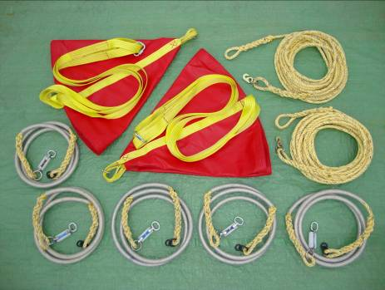

ALL PRICES EXCLUDE VAT, taxes and duties, etc. If no VAT number is supplied, UK VAT rate is 20%.

Prices quoted are valid until 31st March 2012

Skylaunch have a €Euro account but have quoted in £Pounds due to exchange rate fluctuations. Exact Euro rates for Invoicing can be advised at time of payment if required.

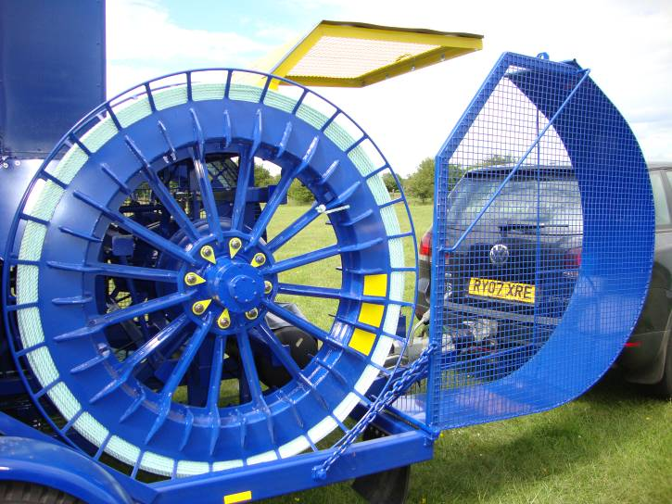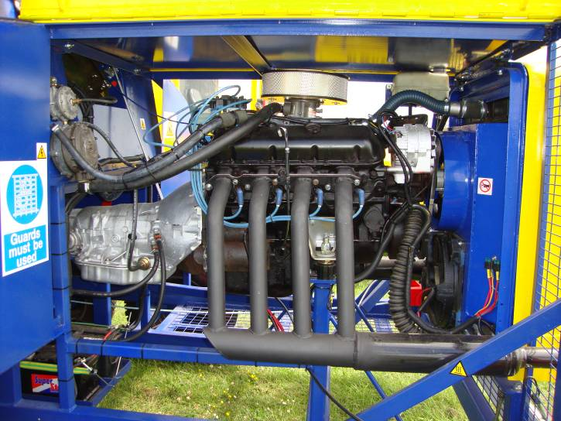

Option (O) for use with Dyneema – Skylaunch Pulley / roller units and high powered chisel Guillotine systems (Below)

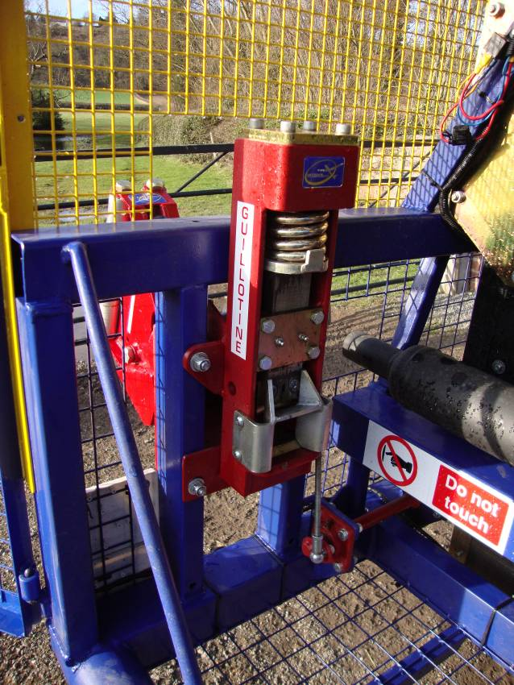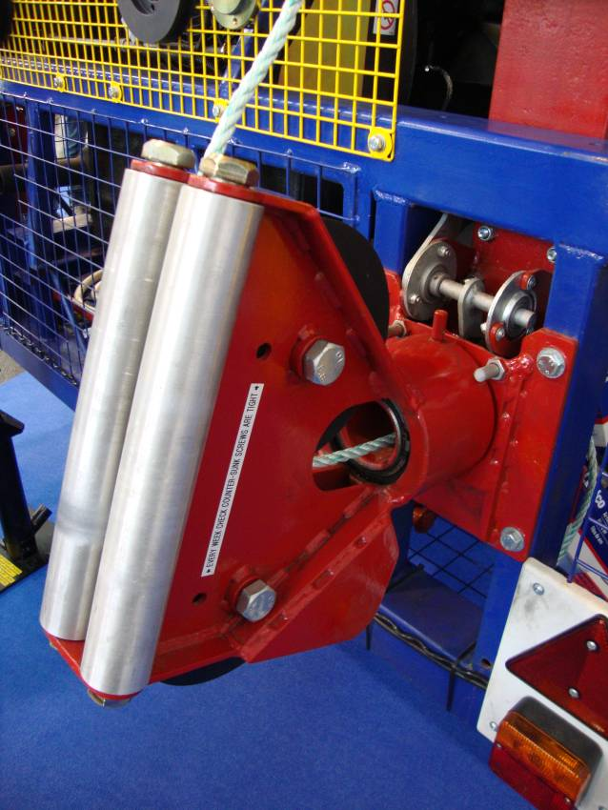

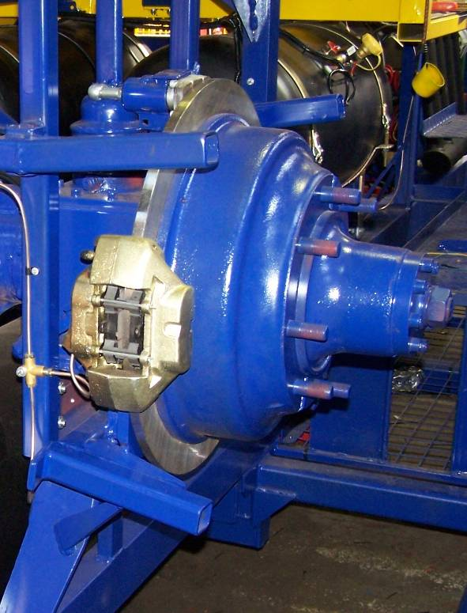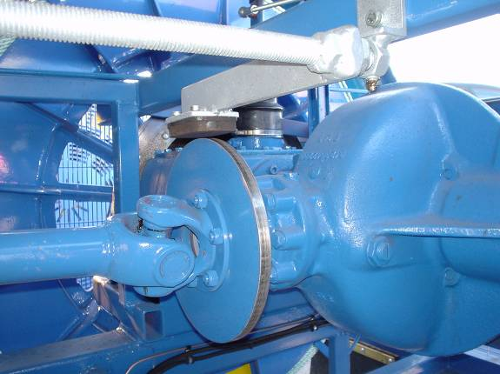

Examples of similar style Cabins. Note: Cabin quoted would be wider than those shown below.

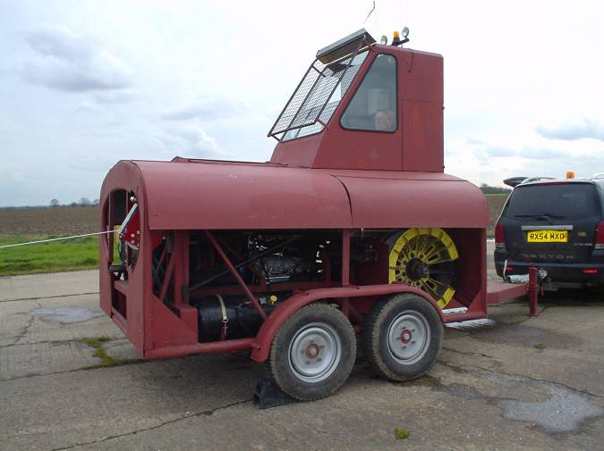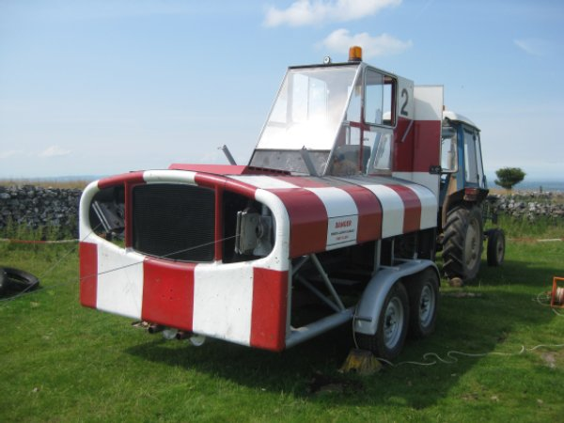

RE-ENGINEERED BY SKYLAUNCH




